Secure Coding Lab-5

Chekuri.mahesh 18BCN7101

# Reflected XSS

## Commands and Outputs:

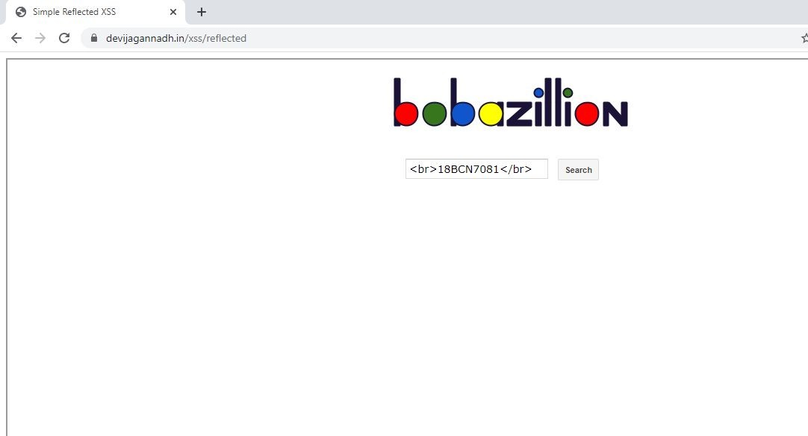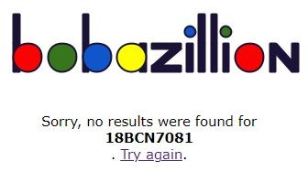1) <br>18BCN7081</br>

* 1. [<a href="https://www.youtube.com">dattu</a>](http://www.youtube.com/)

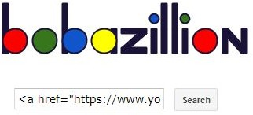

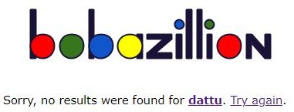

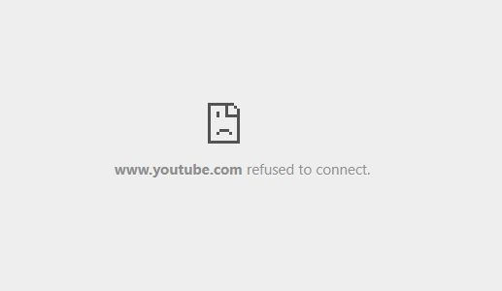When I click on that, it will redirect into the page URL I have given.

* 1. <script>alert(document.cookie);</script>

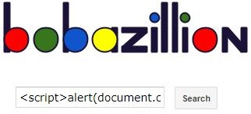

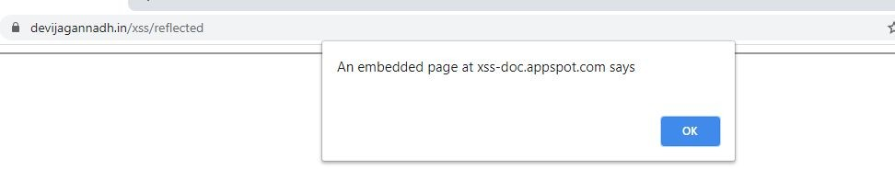The Payload we entered should give a reply with the Session Cookie.

* 1. 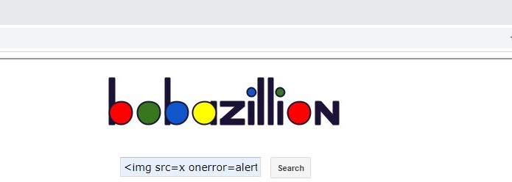<img src=x onerror=alert(document.cookie)>

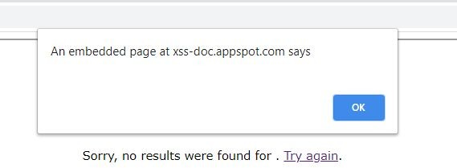The Payload we entered should give a reply with the Session Cookie.

With Advanced Cross Site Scripting, This RXSS can transfer the Victim’s cookie to the Attacker.

# Stored XSS

Commands and Outputs You can see the malicious code and output below

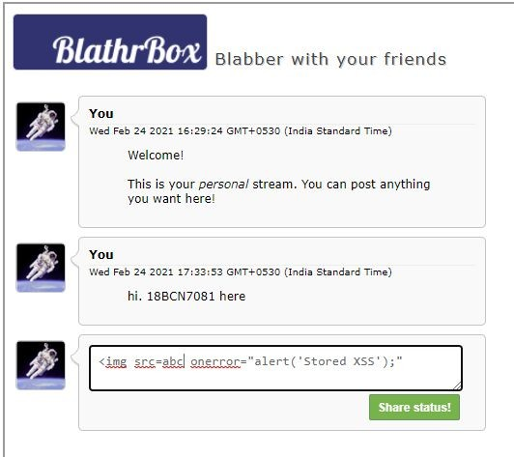1)

friend

•e)

An embedded pape at xss-cloc.appspo\.Cam says

Storec XSS



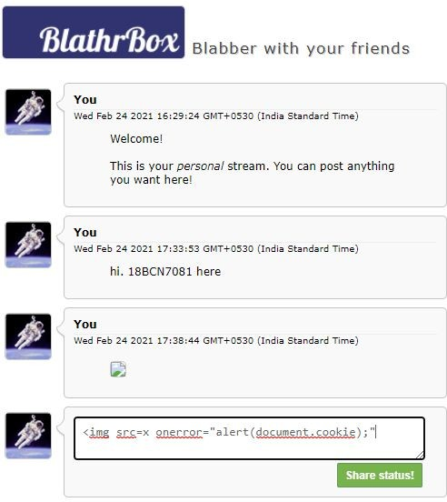2)

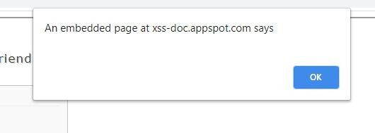

You

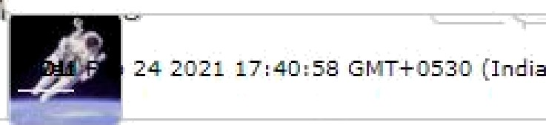\Yed Feb 24 2021 17: 40: i8 GfvIT+0510 (India Sta rsdard Time)



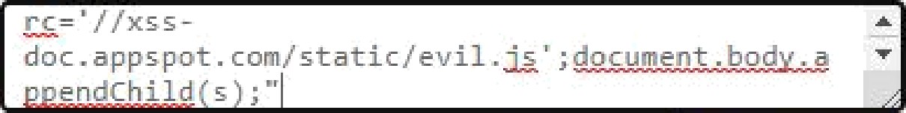

rc = ' / /xs s -

doc . apps pot . con/ stat1c/ev11 .

endChild s ;”

' ; do u e I bod a

•



'0 (Ind ii :Sta nda rd Time j

me)

Web 24 202 1 18 : 03 : 29 £i MT-I-O53O ( Ind ia Sta ndard Time)

Fab 24. 2 17‹3B 44 Gb¥T-I- ”^ ’” -“



021 29:24

This your sE .... .

want here!

Sta 7Jme)

(Ind ia Sfanda rd Time)

can post anything you

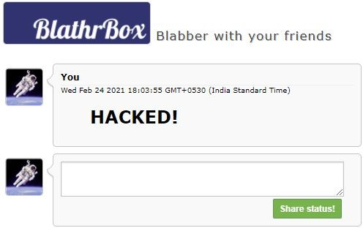

# Dom XSS

## Commands and Outputs:

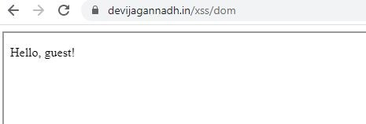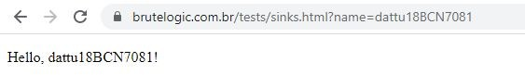

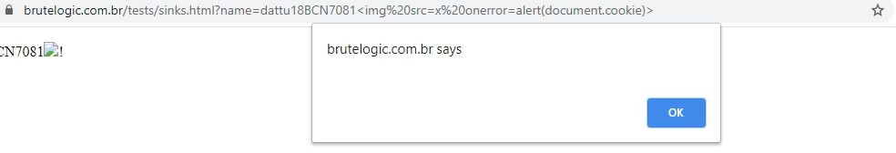

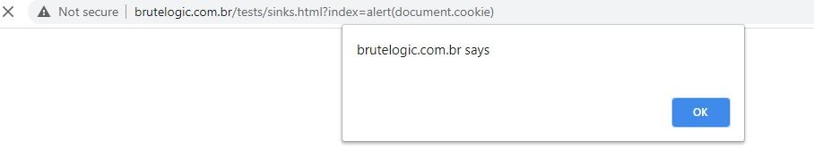

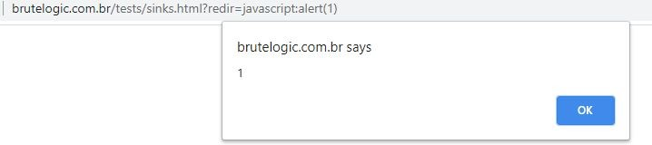

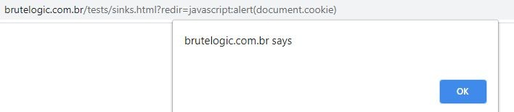

How Secure Coding is related to XSS?

Secure Coding plays a huge role in preventing these XSS attacks. These cross site scripting attacks can only be used in such websites where scripts can be executed even though they are not meant to. Such websites are vulnerable to XSS. These XSS attacks can be prevented by limiting the few characters usable in the fields, such that no malicious payloads/ scripts can be executed in our websites. Nowadays there are numerous websites which are vulnerable to XSS. By implementing some several

restrictions like Character limitation etc, our websites can be secured and will be invulnerable to XSS.

# Challenge:

